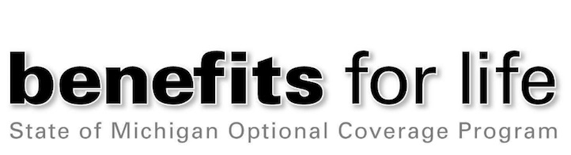
Benefits for Life Open Enrollment is March 8 – 26
Benefits for Life, the voluntary, employee-paid coverage offered through the State of Michigan, provides additional protection with premiums payable through the convenience of payroll deduction. Eligible employees¹ who would like to enroll, review existing coverage, or make changes can visit www.BenefitsforLife.org or call the Benefits for Life Call Center at 888-825-8395, Monday through Friday, 9:00 a.m. to 6:00 p.m.
NOTE: When enrolling online you must register as a new user. Username and passwords created in prior years are no longer valid.
2021 Updates
Legal Plans – Hyatt Legal Plans is now MetLife Legal Plans. Only their name has changed, they will continue to provide the same service as they always have.
You have the option to participate in the legal plan ($9.00 bi-weekly) or the legal plan plus FraudScout ($10.11 bi-weekly). Both plans provide a full year of legal coverage that will be renewed automatically each year and may only be canceled during an open enrollment period.
MetLife Auto & Home – MetLife Auto & Home has entered into an agreement to sell MetLife Auto & Home to Farmers Group Inc., a subsidiary of Zurich Insurance Group. For now, there are no immediate changes to your MetLife Auto & Home policies, and you will maintain your relationship with MetLife Auto & Home. This announcement is the first step in a process and the transaction, which is subject to customary closing conditions and approvals, is targeted to close in the second quarter of 2021. The MetLife customer service team will continue to assist you with account, billing, and service needs.
Visit www.BenefitsforLife.org or call 888-825-8395, March 8 through March 26, 2021 to enroll in:
- IDShield Identity Theft: employee only coverage ($2.19 bi-weekly) or the family plan ($3.58 bi-weekly). Plans provide monitoring, identity restoration, licensed private investigators, consultations, alerts, and more.²
- Trustmark Universal Life Insurance with Long Term Care and/or Trustmark Critical Illness Insurance online without answering medical questions up to specified limits if you do not have prior coverage in these plans.³
- MetLife Supplemental Term Life Insurance, employees can apply for up to $400,000 coverage, spouse up to $70,000, and children up to $10,000 without answering medical questions.³
- MetLife Accidental Death and Dismemberment (AD&D) Insurance, employees and their spouse can enroll in up to $700,000 in coverage and children up to $15,000 in coverage without answering medical questions.³
- MetLife Legal Plans: your choice of the Legal Plan or the Legal Plan plus FraudScout Plan that includes Triple Bureau Monitoring.³
- Trustmark Enhanced Accident Insurance: offsets the cost of unexpected bills related to accidents. The plan provides benefits if you require hospitalization for a covered non-occupational accident or injury.³
- Auto and Home Insurance through Liberty Mutual or MetLife with exclusive employee savings.³
- Free Abenity Discount Plan: requires enrollment each year to receive local and national perks and discounts, from groceries, computers, technology, hotels, restaurants, theme parks, and more.
For more information, review the materials and watch the Benefits for Life videos on the Employee Benefits Division website, www.mi.gov/employeebenefits, by selecting “Voluntary Benefits” from the left menu, then “Active Employees.”

¹Non-career and Special Personal Services (SPS) employees are not eligible for this benefit.
²IDShield is a product of LegalShield and provides access to identity theft protection and restoration services. For complete terms, coverage, and conditions, please see a summary plan description. Licensed Private Investigators are licensed in the state of Oklahoma. $1 Million protection policy is issued by a leading insurance carrier. Certain limitations apply.
³Exclusions, limitations, and restrictions may apply. Trustmark products may be available on a guaranteed issue or modified guaranteed issue basis (some exceptions may apply). Review plan documents and certificates in the “Benefit Information” section at www.BenefitsforLife.org for complete details.

